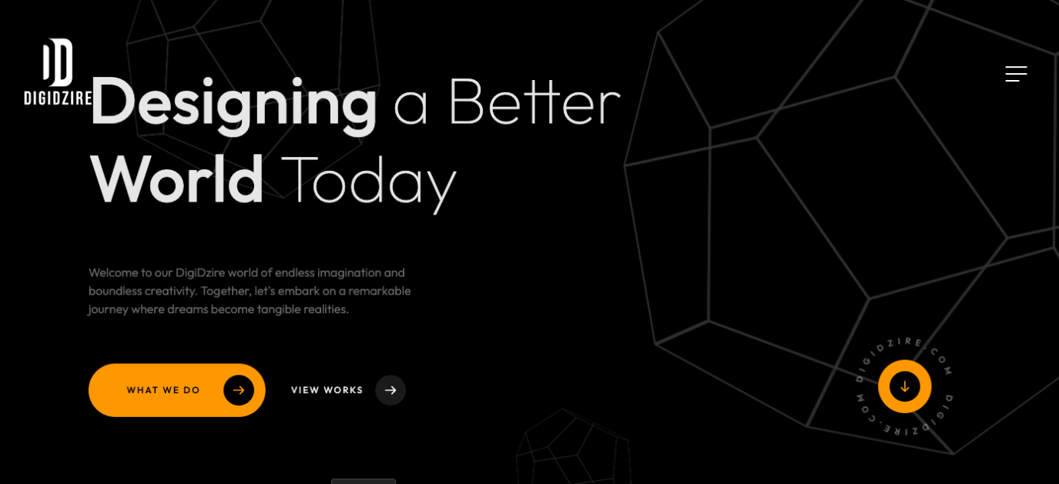

Designing a Better World Today

Hi Peeps!

Enter into the world of designing and technology with team Digidzire. We are a group of professional wizards helping you with creative designs, video animations, technology, development, brand identity and much more.

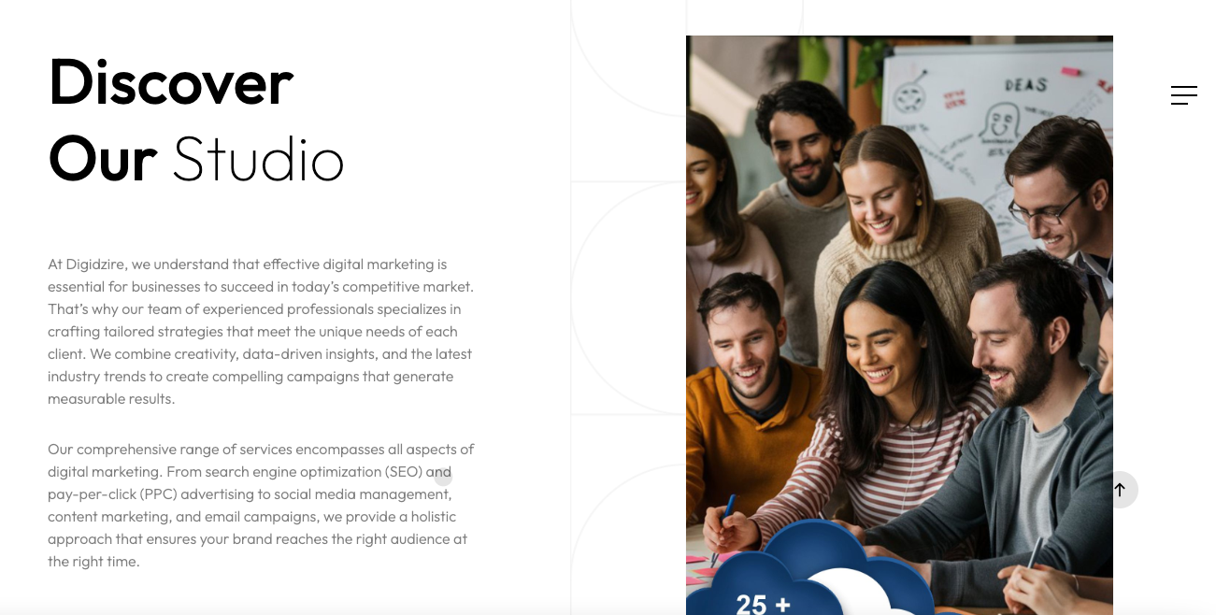

Discover Our Studio

About Us

Welcome to Digidzire – Your Premier IT and Design Partner!

At Digidzire, we are passionate about transforming your vision into reality through innovative design and cutting-edge IT solutions. As experts in building brand identities and comprehensive marketing strategies, we pride ourselves on delivering exceptional results that drive business growth and enhance brand recognition.

Who We Are:

Digidzire is a dynamic IT and design company specializing in crafting compelling brand identities and robust digital marketing solutions. Our team of creative designers, strategic marketers, and tech-savvy developers work collaboratively to create unique and impactful experiences for our clients. With a deep understanding of the latest trends and technologies, we ensure that your brand stands out in the competitive market.

What’s Unique with us?

- Innovative Solutions: We stay ahead of industry trends to provide innovative solutions that set your brand apart in the digital world.

- Customer-Centric Approach: Our clients are at the heart of everything we do. We work closely with you to understand your goals and deliver tailored solutions that meet your unique needs.

- Results-Driven Strategies: We focus on delivering measurable results, ensuring that every project contributes to your business growth and success.

- Expert Team: Our skilled professionals bring a wealth of experience and expertise to every project, ensuring top-notch quality and execution.

Our Mission:

At Digidzire, our mission is to empower businesses by creating impactful brand identities and implementing effective marketing strategies that drive success. We are dedicated to helping you achieve your business goals through creativity, innovation, and technical excellence.

SEO Keywords:

IT and Design Company, Brand Identity Creation, Web Design and Development, Digital Marketing Solutions, SEO Services, Graphic Design, Digidzire, Innovative Solutions, Customer-Centric Approach, Results-Driven Strategies, Expert Team, Business Growth, Online Visibility, Brand Recognition, Empowering Businesses, Creative Designers, Strategic Marketers.

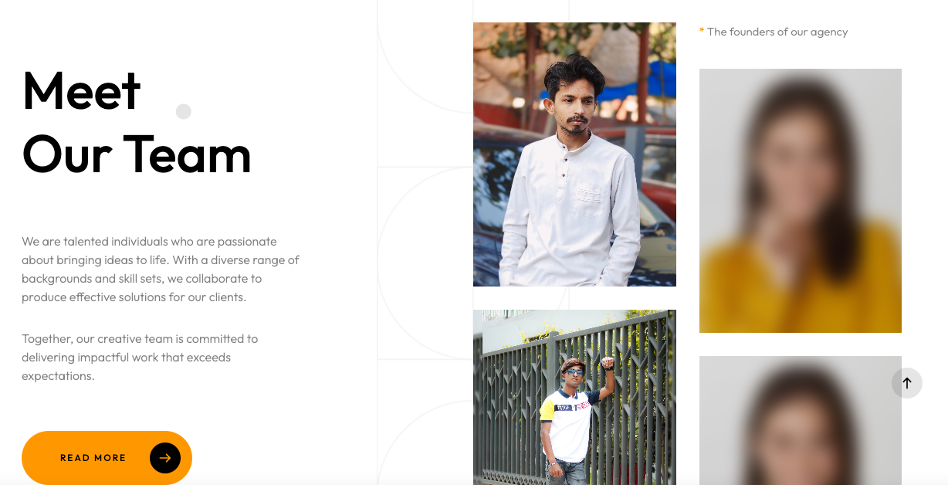

**Meet the Digidzire Dream Team!**

The minds behind the magic! Here, you'll get to know the passionate go-getters who make Digidzire tick. We're a creative bunch with a shared mission to craft cutting-edge digital solutions for our clients. Dive in and meet the wizards behind the clicks!

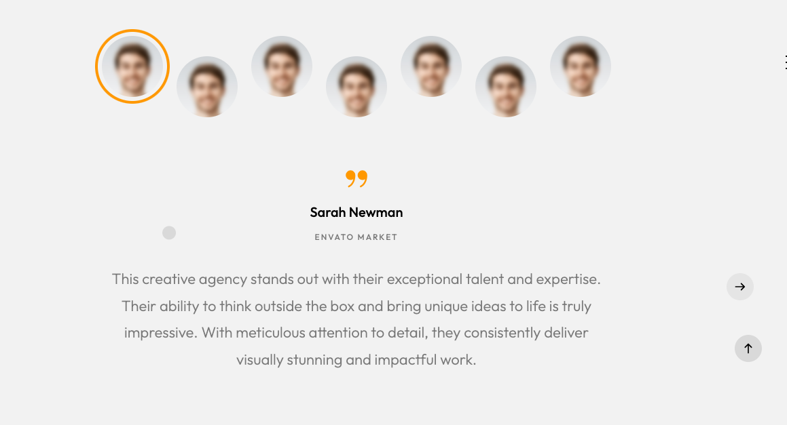

1. Digidzire's data-driven approach and creative flair completely transformed our social media presence. We've seen a significant increase in brand awareness and engagement, and our lead generation has skyrocketed. We wouldn't hesitate to recommend their services to any business looking to take their digital marketing to the next level.
2. Digidzire team is incredibly responsive, knowledgeable, and results-oriented. They developed a comprehensive SEO strategy that has propelled our website to the top of search engine rankings, driving a surge in organic traffic and sales.
3. We were struggling to connect with a younger demographic. Digidzire's team developed a captivating influencer marketing campaign that resonated perfectly with our target audience. The campaign generated significant brand buzz and positive brand sentiment, achieving a remarkable increase in brand loyalty.
4. Digidzire's commitment to transparency and clear communication sets them apart. They provide regular reports and in-depth analysis, allowing us to track progress and make informed decisions. We feel like true partners in our digital marketing journey.
5. Our online presence was stagnant before we partnered with Digidzire. Their team completely revamped our social media strategy and developed targeted PPC campaigns. Within months, we saw a dramatic increase in brand awareness and engagement. Digidzire's expertise and dedication were instrumental in our digital growth.
6. We were initially hesitant to outsource our digital marketing, but Digidzire quickly exceeded our expectations. Their team is incredibly knowledgeable and always goes the extra mile to ensure our success. From SEO optimization to website development, Digidzire has provided us with exceptional service across the board.
7. Finding a digital marketing agency that balances creativity with strategic thinking can be a challenge. Digidzire strikes the perfect balance. Their team consistently delivers innovative campaigns that are backed by sound data and analytics. We've seen a remarkable improvement in our conversion rates and overall ROI since partnering with Digidzire.

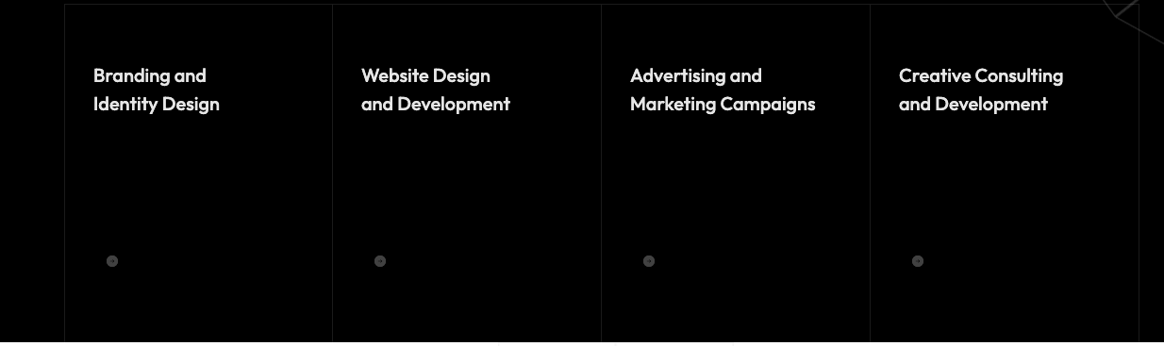

Digidzire is your one-stop shop for crafting a powerful digital presence. We offer a comprehensive suite of services designed to elevate your brand, attract your ideal audience, and drive results.

**1. Branding & Identity Design:**

* **Become unforgettable:** We'll define your brand essence, crafting a unique visual language (logo, color palette, fonts) and messaging that resonates with your target audience.
* **Stand out from the crowd:** Our branding experts will create a cohesive brand identity that sets you apart in a competitive marketplace.
* **Build trust and connection:** A strong brand identity fosters trust and emotional connection with your customers.

**2. Website Design & Development:**

* **Create a digital masterpiece:** We design and develop beautiful, user-friendly websites that are optimized for performance and conversions.
* **Seamless user experience:** Our focus is on intuitive navigation, clear calls to action, and a responsive design that adapts to any device.
* **Make a lasting impression:** Your website is your online storefront; let us create a space that reflects your brand and compels visitors to engage.

**3. Advertising & Marketing Campaigns:**

* **Reach the right audience, at the right time:** We develop data-driven marketing campaigns that target your ideal customers across various channels.
* **Maximize your ROI:** Our strategic approach to social media, search engine marketing (SEM), and display advertising ensures you get the most out of your marketing budget.
* **Track and analyze results:** We measure campaign performance and constantly optimize strategies to deliver the best possible outcomes.

**4. Creative Photoshoot & Video Creation:**

* **Tell your brand story visually:** Our team of photographers and videographers will create stunning, high-quality content that showcases your brand and products in the best light.
* **Captivate your audience:** Engaging visuals are essential for grabbing attention and boosting engagement on your website and social media channels.
* **Leave a lasting impression:** Professional photos and videos elevate your brand and build a stronger connection with your audience.

Exceptional Graphic Design Services at Digidzire

At Digidzire, we believe that great design is at the heart of every successful brand. Our graphic design services are tailored to bring your vision to life, creating visually compelling and memorable experiences that resonate with your audience. Whether you need a new logo, marketing materials, or a complete brand overhaul, our team of talented designers is here to deliver exceptional results.

**Our Graphic Design Services:**

1. Logo Design:

- Unique and Memorable Logos: We craft distinctive logos that capture the essence of your brand, ensuring it stands out in a crowded marketplace.

- Versatile Designs: Our logos are designed to look great across all platforms, from business cards to billboards.

2. Brand Identity:

- Comprehensive Brand Packages: We develop cohesive brand identities that include logos, color schemes, typography, and visual elements that reflect your brand’s personality and values.

- Brand Guidelines: We provide detailed brand guidelines to ensure consistency across all your marketing materials.

3. Marketing Collateral:

- Brochures and Flyers: Eye-catching designs that effectively communicate your message and engage your audience.

- Business Cards: Professionally designed business cards that leave a lasting impression.

- Posters and Banners: High-impact designs for events, promotions, and advertising campaigns.

4. Digital Graphics:

- Social Media Graphics: Custom graphics for social media platforms that enhance your online presence and attract engagement.

- Website Graphics: Visually appealing website elements, including banners, icons, and infographics, that enhance user experience and visual appeal.

- Email Campaigns: Attractive email templates and graphics that boost your email marketing efforts.

5. Packaging Design:

- Innovative Packaging: Creative and functional packaging designs that highlight your product and appeal to consumers.

- Label Design: Detailed and attractive label designs that provide essential information and catch the consumer’s eye.

Why Choose Digidzire for Graphic Design?

- Creative Excellence: Our team of designers is passionate about creativity and innovation, ensuring each project is unique and impactful.

- Tailored Solutions: We understand that every brand is different, and we tailor our designs to meet your specific needs and objectives.

- Attention to Detail: From the initial concept to the final design, we pay meticulous attention to every detail, ensuring flawless execution.

- Collaborative Approach: We work closely with you throughout the design process, incorporating your feedback to create designs that truly reflect your vision.

- Timely Delivery: We respect your deadlines and strive to deliver high-quality designs within the agreed timeframe.

Enhance Your Designing Game with Digidzire:

Great design is more than just aesthetics; it’s about creating a connection with your audience. At Digidzire, we combine creativity, strategy, and technical expertise to deliver graphic design solutions that elevate your brand and drive results. Let us help you make a lasting impression with stunning visuals that tell your brand’s story.

SEO Keywords:

Graphic Design Services, Logo Design, Brand Identity, Marketing Collateral, Digital Graphics, Packaging Design, Creative Excellence, Custom Graphics, Unique Logos, Brand Guidelines, Social Media Graphics, Website Graphics, Packaging Design, Digidzire, Creative Design Solutions, Tailored Design Services.

Expert Content Marketing and SEO Services at Digidzire

Unlock the Power of Words and Search

In today's digital landscape, content is king and search engine visibility is vital. At Digidzire, we offer comprehensive content marketing and SEO services designed to elevate your online presence, engage your audience, and drive sustainable growth. Our team of experienced content creators and SEO specialists work together to craft compelling narratives and optimize your digital footprint, ensuring your brand stands out in the crowded online marketplace.

**Our Content Marketing Services:**

1. Strategic Content Planning:

- Content Audits: We analyze your existing content to identify strengths, weaknesses, and opportunities for improvement.

- Content Strategy Development: We create a tailored content strategy aligned with your business goals and audience needs.

2. Content Creation:

- Blog Writing: Engaging and informative blog posts that establish your brand as an industry authority and drive organic traffic.

- Website Content: Clear, compelling copy for your website that enhances user experience and communicates your value proposition.

- Whitepapers and Ebooks: In-depth, well-researched content pieces that provide valuable insights and generate leads.

- Social Media Content: Tailored posts, graphics, and videos designed to engage and grow your social media following.

3. Content Distribution:

- Social Media Sharing: Leveraging social platforms to amplify your content reach and engage with your audience.

- Email Marketing: Crafting targeted email campaigns that nurture leads and drive conversions.

- Guest Blogging: Strategic guest posts on high-authority sites to increase your brand’s visibility and credibility.

**Our SEO Services:**

1. Keyword Research and Analysis:

- Competitive Analysis: Identifying keyword opportunities and gaps by analyzing your competitors’ strategies.

- Keyword Strategy: Developing a targeted keyword strategy to optimize your content for search engines.

2. On-Page SEO:

- Meta Tags Optimization: Crafting optimized title tags, meta descriptions, and header tags to improve click-through rates and rankings.

- Content Optimization: Enhancing your website’s content with targeted keywords, internal linking, and multimedia elements.

- Technical SEO: Improving site speed, mobile-friendliness, and overall site structure to ensure a seamless user experience.

3. Off-Page SEO:

- Link Building: Building high-quality backlinks through outreach, guest blogging, and digital PR strategies.

- Local SEO: Optimizing your Google My Business listing and local citations to improve your local search visibility.

- Social Signals: Leveraging social media activity to boost your search engine rankings and online authority.

4. SEO Analytics and Reporting:

- Performance Tracking: Monitoring your website’s performance using tools like Google Analytics and Search Console.

- Detailed Reports: Providing regular reports on key metrics, insights, and recommendations for continuous improvement.

Why Choose Digidzire for Content Marketing and SEO?

- Holistic Approach: We combine the art of storytelling with the science of SEO to create content that resonates with your audience and ranks well in search engines.

- Customized Solutions: Our strategies are tailored to your unique business needs, ensuring maximum impact and ROI.

- Experienced Team: Our content creators and SEO specialists bring a wealth of experience and expertise to every project.

- Data-Driven Decisions: We rely on data and analytics to guide our strategies and measure success.

- Results-Oriented: Our primary focus is on delivering tangible results that drive traffic, engagement, and conversions.

Transform Your Online Presence with Digidzire:

At Digidzire, we are dedicated to helping your brand succeed in the digital world. Our content marketing and SEO services are designed to enhance your online presence, build lasting relationships with your audience, and achieve your business goals. Let us help you unlock the full potential of your content and search strategy.

SEO Keywords:

Content Marketing Services, SEO Services, Content Creation, Keyword Research, On-Page SEO, Off-Page SEO, Digital Marketing, Blog Writing, Website Content, Social Media Content, Link Building, Local SEO, SEO Analytics, Digidzire, Search Engine Optimization, Content Strategy, Online Visibility, Digital Presence.

Comprehensive Social Media Marketing Services at Digidzire

Harness the Power of Social Media for Your Business

In the ever-evolving digital landscape, social media has become an essential tool for businesses to connect with their audience, build brand awareness, and drive engagement. At Digidzire, our expert Social Media Marketing (SMM) services are designed to help you navigate this dynamic environment, creating impactful campaigns that resonate with your audience and achieve your business goals.

**Our Social Media Marketing Services:**

1. Social Media Strategy Development:

- Customized Strategies: We develop tailored social media strategies that align with your brand’s goals, target audience, and industry trends.

- Competitor Analysis: We conduct thorough competitor analysis to identify opportunities and benchmark your social media performance.

2. Content Creation and Curation:

- Engaging Posts: Crafting visually appealing and compelling content that captures your brand’s voice and engages your audience.

- Multimedia Content: Producing high-quality images, videos, infographics, and more to enhance your social media presence.

- Content Calendar: Planning and scheduling content to ensure a consistent and cohesive posting schedule.

3. Community Management:

- Audience Engagement: Actively engaging with your followers by responding to comments, messages, and reviews to build a loyal community.

- Reputation Management: Monitoring and managing your online reputation, addressing customer concerns, and promoting positive interactions.

4. Paid Social Media Advertising:

- Targeted Campaigns: Creating and managing targeted ad campaigns on platforms like Facebook, Instagram, LinkedIn, and Twitter to reach your ideal audience.

- Budget Optimization: Maximizing your ad spend by optimizing campaigns for the best possible return on investment (ROI).

- Performance Tracking: Continuously monitoring and adjusting campaigns based on performance metrics to ensure optimal results.

5. Influencer Marketing:

- Influencer Partnerships: Identifying and collaborating with relevant influencers to amplify your brand’s reach and credibility.

- Campaign Management: Managing influencer campaigns from start to finish, including contract negotiation, content approval, and performance tracking.

6. Analytics and Reporting:

- In-Depth Analysis: Providing detailed insights into your social media performance, including engagement rates, follower growth, and campaign effectiveness.

- Regular Reports: Delivering regular reports with actionable recommendations to continually improve your social media strategy.

Why Choose Digidzire for Social Media Marketing?

- Expert Team: Our team of social media specialists brings a wealth of experience and creativity to every campaign.

- Tailored Approach: We understand that every business is unique, and we tailor our strategies to meet your specific needs and objectives.

- Engaging Content: We create content that not only looks great but also drives meaningful engagement and builds a strong connection with your audience.

- Data-Driven Decisions: Our strategies are backed by data and analytics, ensuring that every decision is informed and effective.

- Proven Results: We focus on delivering measurable results that contribute to your business growth and success.

Boost Your Social Media Presence with Digidzire:

At Digidzire, we are dedicated to helping your brand thrive on social media. Our comprehensive SMM services are designed to elevate your online presence, foster engagement, and drive conversions. Let us help you unlock the full potential of social media for your business.

SEO Keywords:

Social Media Marketing Services, Social Media Strategy, Content Creation, Community Management, Paid Social Media Advertising, Influencer Marketing, Social Media Analytics, Social Media Engagement, Digidzire, Social Media Presence, Online Reputation Management, Social Media Campaigns, Targeted Ad Campaigns, Audience Engagement, Digital Marketing, Social Media Experts.

Capturing Perfection: Professional Photoshoot Services at Digidzire

At Digidzire, we understand the power of a compelling image. Whether it’s for a brand campaign, product launch, or personal portfolio, our professional photoshoot services are designed to capture the essence of your vision with stunning visuals. Our team of skilled photographers and creative directors work collaboratively to deliver high-quality images that tell your story and elevate your brand.

**Our Photoshoot Services:**

1. Corporate and Business Photography:

- Executive Portraits: Professional headshots and executive portraits that reflect your brand’s professionalism and personality.

- Office Environment: Capturing the essence of your workplace with dynamic and engaging office environment shots.

- Team Photos: Showcasing the people behind your brand with team photos that highlight your company culture.

2. Product Photography:

- E-commerce Shots: High-resolution product images optimized for online stores and marketplaces, ensuring your products stand out.

- Lifestyle Shots: Creative lifestyle photography that showcases your products in real-world settings, enhancing their appeal.

- Detail Shots: Close-up images that highlight the intricate details and quality of your products.

3. Event Photography:

- Corporate Events: Documenting your conferences, seminars, and corporate gatherings with professional event photography.

- Brand Activations: Capturing the excitement and engagement at your brand activation events.

- Private Events: Providing coverage for personal events such as weddings, birthdays, and anniversaries.

4. Fashion and Lifestyle Photography:

- Model Portfolios: Creating stunning portfolios for aspiring models with professional fashion photography.

- Editorial Shoots: Producing high-fashion editorial shoots for magazines and fashion blogs.

- Lifestyle Campaigns: Crafting lifestyle images that resonate with your target audience and convey your brand’s story.

Book Your Photoshoot with Digidzire:

At Digidzire, we are committed to capturing the perfect shot every time. Our comprehensive photoshoot services are designed to meet all your photography needs, from corporate and product photography to fashion and lifestyle shoots. Let us help you create stunning visual stories that leave a lasting impression.

SEO Keywords:

Photoshoot Services, Professional Photography, Corporate Photography, Product Photography, Event Photography, Fashion Photography, Lifestyle Photography, Real Estate Photography, Digidzire, High-Quality Images, Creative Direction, Customized Photoshoot, Photography Experts, Visual Storytelling, Professional Headshots, E-commerce Product Images.

Elevate Your Brand with Premium Print Media Solutions at Digidzire

From Concept to Creation: Superior Print Media Services

In a digital age, the tactile experience of print media remains a powerful tool for brand communication. At Digidzire, we specialize in delivering premium print media solutions that captivate your audience and convey your message with clarity and impact. Our team of design and print experts works meticulously to bring your vision to life, ensuring every piece of print media reflects your brand’s identity and values.

**Our Print Media Services:**

1. Business Essentials:

- Business Cards: Create lasting impressions with professionally designed business cards that convey your brand’s identity.

- Letterheads and Envelopes: Enhance your corporate correspondence with custom letterheads and envelopes that exude professionalism.

- Brochures and Flyers: Inform and engage your audience with beautifully designed brochures and flyers that highlight your products or services.

2. Marketing Materials:

- Posters and Banners: Capture attention with high-quality posters and banners perfect for events, promotions, and advertising.

- Catalogs and Booklets: Showcase your products and services with comprehensive catalogs and booklets that are both informative and visually appealing.

- Direct Mail: Reach your audience directly with personalized direct mail campaigns, including postcards, newsletters, and promotional materials.

3. Event Collateral:

- Invitations and Announcements: Make a statement with elegantly designed invitations and announcements for corporate events, weddings, and special occasions.

- Event Programs: Ensure your events run smoothly with professionally printed event programs that guide your guests and enhance their experience.

- Signage: Create cohesive event branding with custom signage, including directional signs, welcome banners, and more.

4. Packaging and Labels:

- Product Packaging: Design and produce eye-catching packaging that not only protects your product but also enhances its appeal.

- Labels and Stickers: Customize your product presentation with high-quality labels and stickers that stand out on shelves.

- Gift Wrap and Bags: Elevate your brand with branded gift wrap and bags that add a touch of elegance to your offerings.

5. Specialty Printing:

- Custom Prints: Explore unique print solutions tailored to your specific needs, including bespoke prints, art reproductions, and more.

- Corporate Gifts: Impress clients and employees with high-quality printed corporate gifts, such as notebooks, calendars, and promotional items.

- Large Format Printing: Make a big impact with large format printing solutions, ideal for trade shows, exhibitions, and outdoor advertising.

Why Choose Digidzire for Print Media?

- Expert Craftsmanship: Our team of skilled designers and print specialists is dedicated to delivering superior quality and craftsmanship in every project.

- Custom Solutions: We offer personalized print media solutions tailored to your brand’s unique needs and objectives.

- Attention to Detail: From initial concept to final print, we ensure every detail is meticulously crafted to achieve the desired impact.

- High-Quality Materials: We use only the finest materials and printing techniques to ensure your print media stands out and makes a lasting impression.

- Sustainable Practices: We are committed to environmentally friendly practices, offering sustainable printing options to reduce your carbon footprint.

Transform Your Print Media with Digidzire:

At Digidzire, we believe in the power of print to elevate your brand and communicate your message effectively. Our comprehensive print media services are designed to meet all your printing needs, from business essentials to large-scale marketing campaigns. Let us help you create print materials that captivate and inspire.

SEO Keywords:

Print Media Services, Business Cards, Brochures, Flyers, Posters, Banners, Catalogs, Booklets, Direct Mail, Event Collateral, Invitations, Announcements, Packaging, Labels, Custom Prints, Corporate Gifts, Large Format Printing, Digidzire, High-Quality Printing, Professional Print Solutions, Sustainable Printing Practices, Print Marketing Materials, Superior Print Quality.

Website , application pending